Parth Babbar

cybersecurity measures & incident response

AIM:
The aim of this report is to examine cybersecurity controls and incident response in US institutions. The study examines trends and promotes data-driven decision-making to improve cybersecurity policies by assessing important indicators such as incident frequency, response times, financial implications, and security standard compliance.
Features:
- Bank_ID (integer): A unique identification for each bank.
- Number_of_Cybersecurity_Incidents (integer): The total number of cybersecurity incidents reported by each bank.
- Average_Response_Time_Hours (float): The average number of hours it takes the bank to respond to cybersecurity problems.
- Cost_of_Breaches_millions(float): The monetary cost of breaches in millions of dollars.
- Compliance_with_Security_Standards(integer): A binary indication of whether the bank adheres to recognized security requirements (0 for no and 1 for yes).
- User_Awareness_Levels_percent (float): The percentage of users who are aware of appropriate practices for cybersecurity.
- Number_of_Phishing_Incidents (integer): The total number of phishing events recorded.
- Number_of_Malware_Incidents (integer): The total number of malware occurrences recorded.
- Number_of_Ransomware_Incidents (integer): The total number of ransomware occurrences recorded.
- Average_Detection_Time_Hours (float): The average number of hours required to identify cybersecurity problems.
- Number_of_Employees_in_IT_Security (integer): The total number of employees committed to IT security at the bank.
- Annual_Cybersecurity_Budget_millions(float): The annual budget for cybersecurity measures, in millions of dollars.
- Number_of_Security_Audits_Conducted_Annually (integer): The number of security audits performed yearly.
- Number_of_Security_Tools_Deployed (integer): The number of various security tools used by the bank.
Methodology:
- Data Collection: The dataset was created using information from ChatGPT and the federal reserve.
- Data Cleaning: Python was used to clean the data and assure its integrity. This includes dealing with missing values, transforming 'yes' and 'no' replies to 1 and 0, respectively.
- Visualization: Data visualization tools, such as tableau, were utilized to generate charts and graphs that depict significant discoveries and patterns within the dataset.
Output:

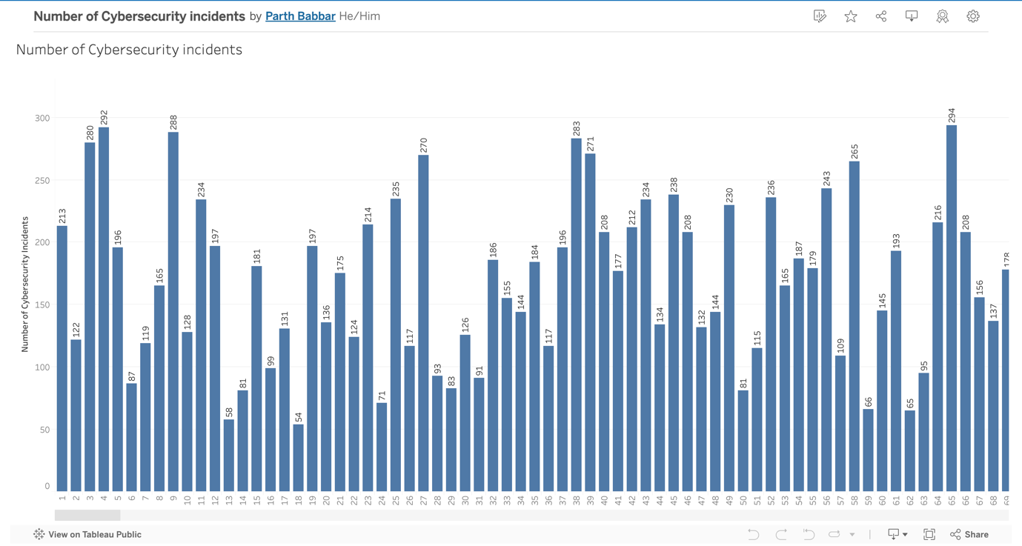

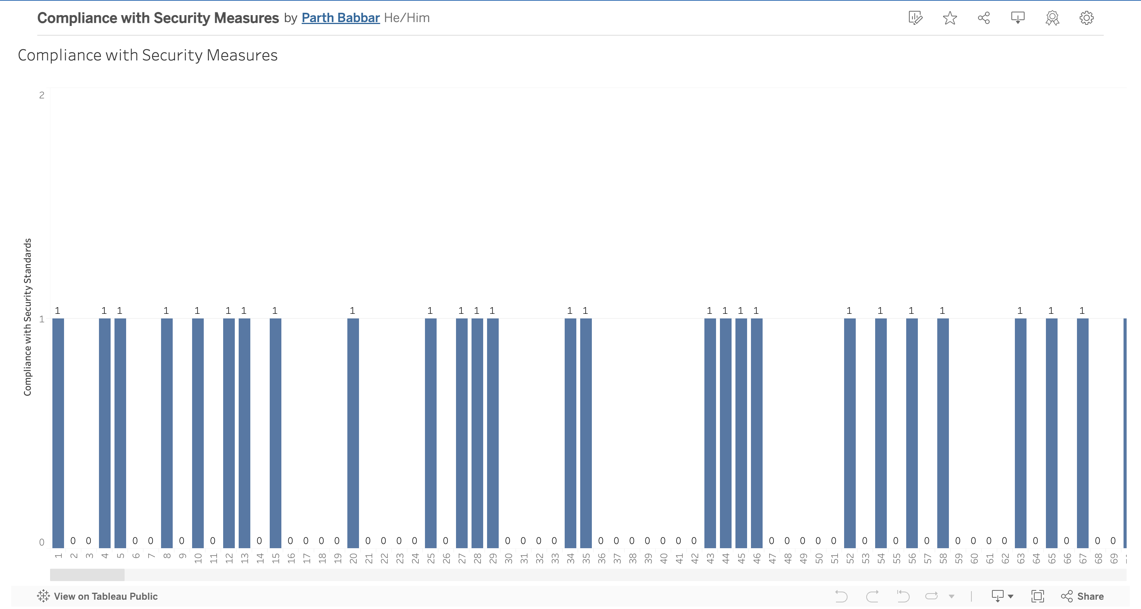

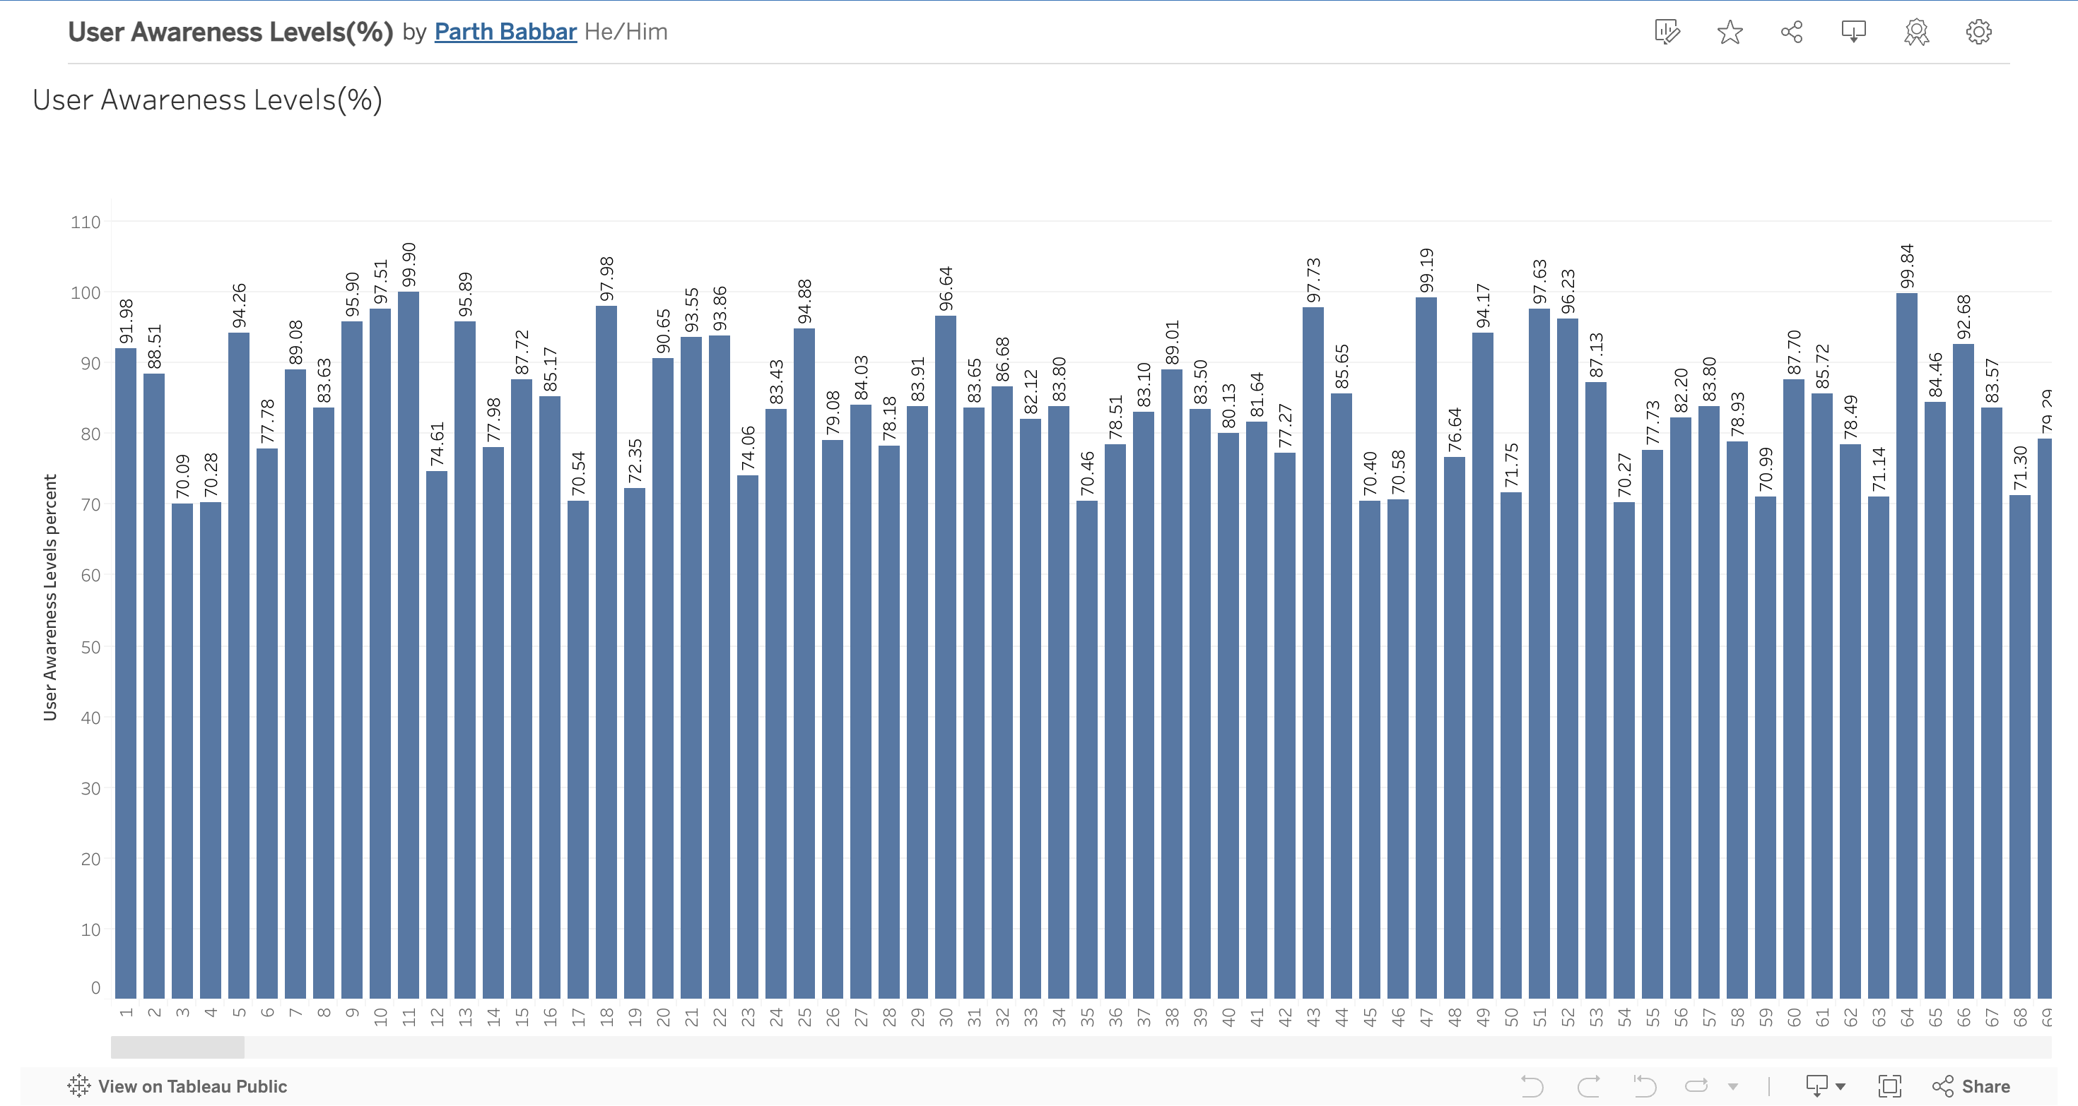

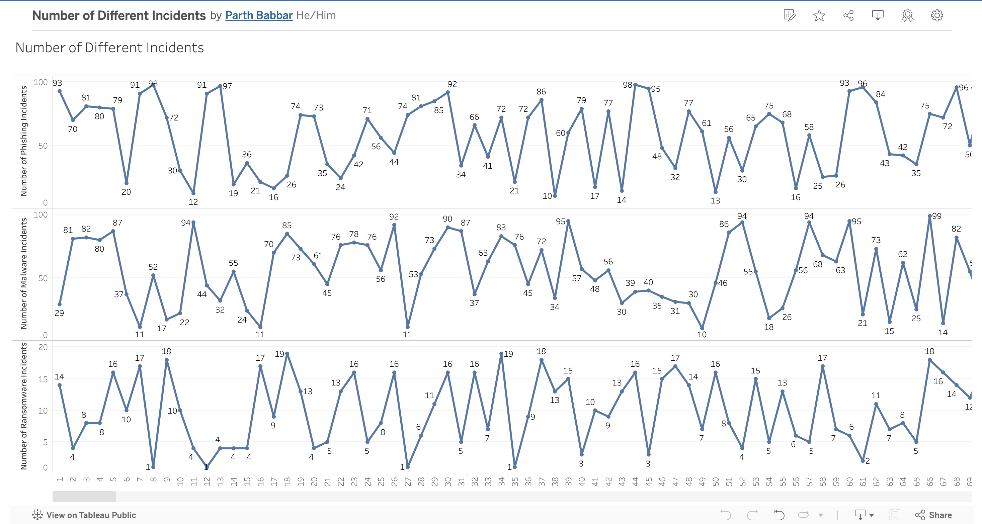

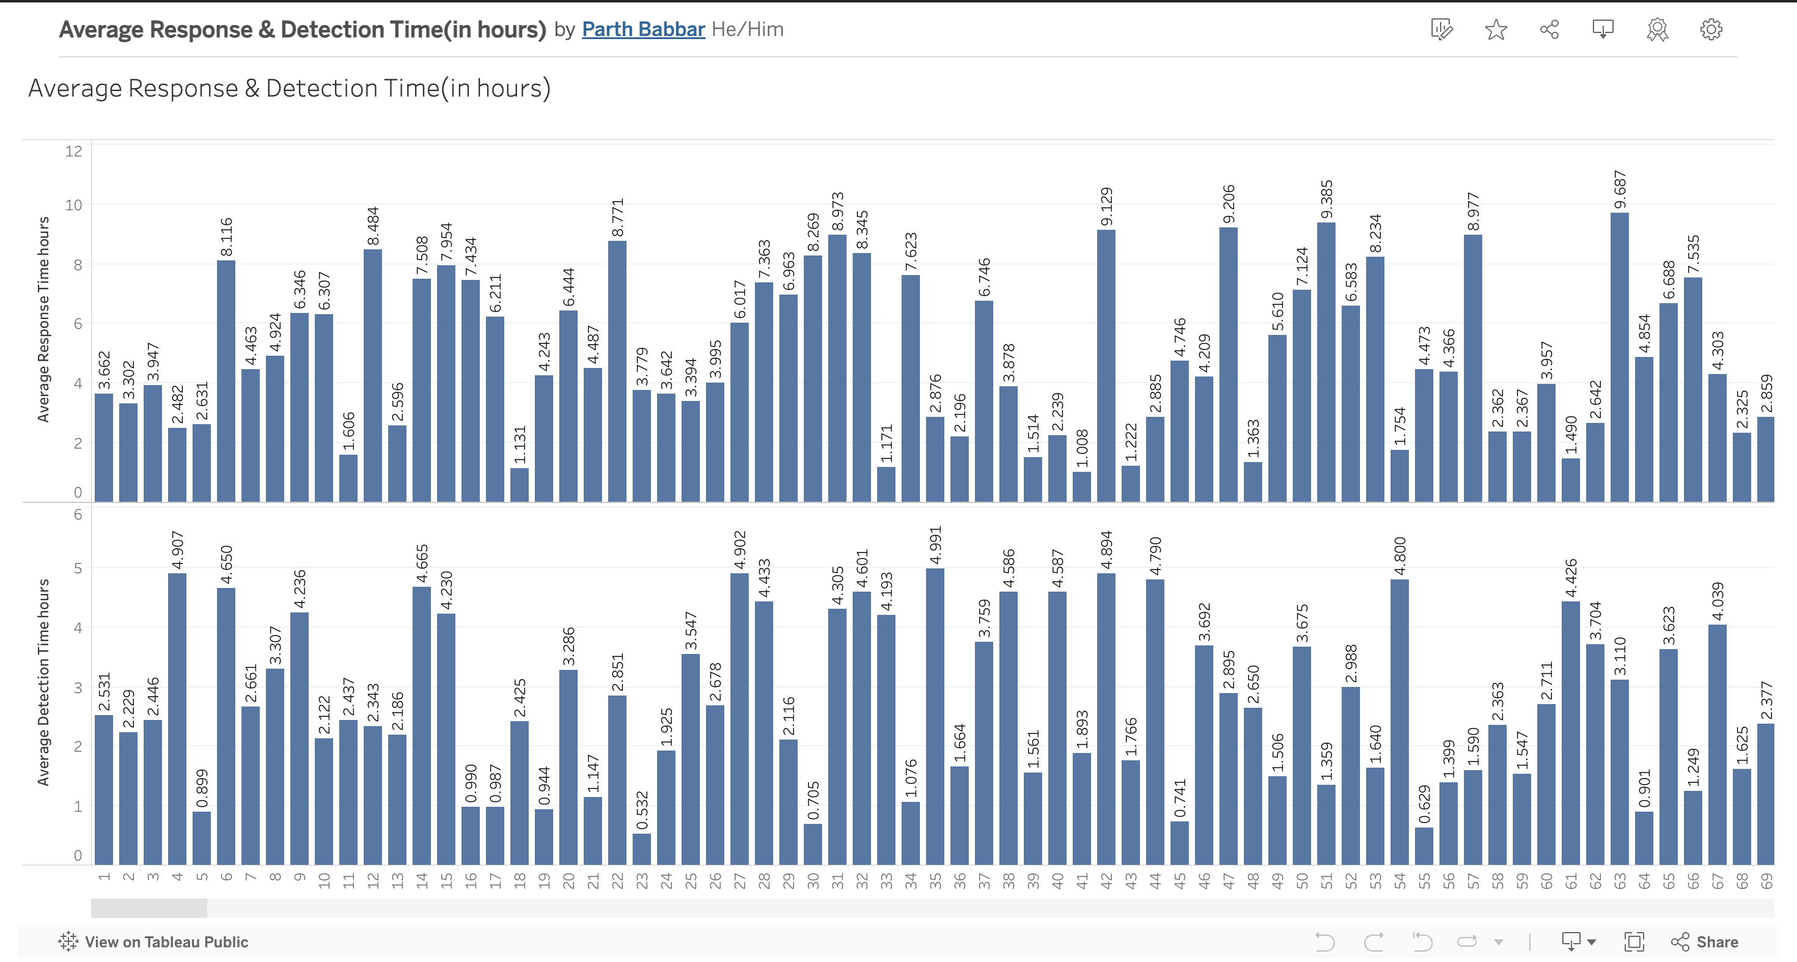

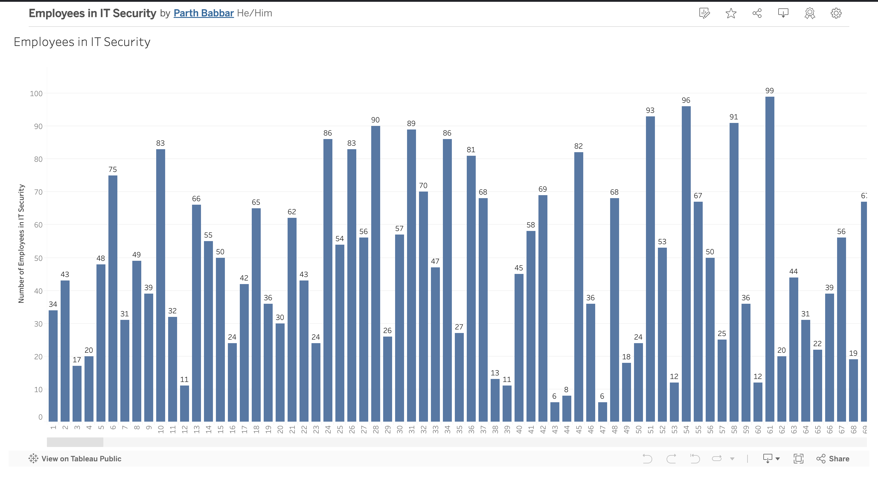

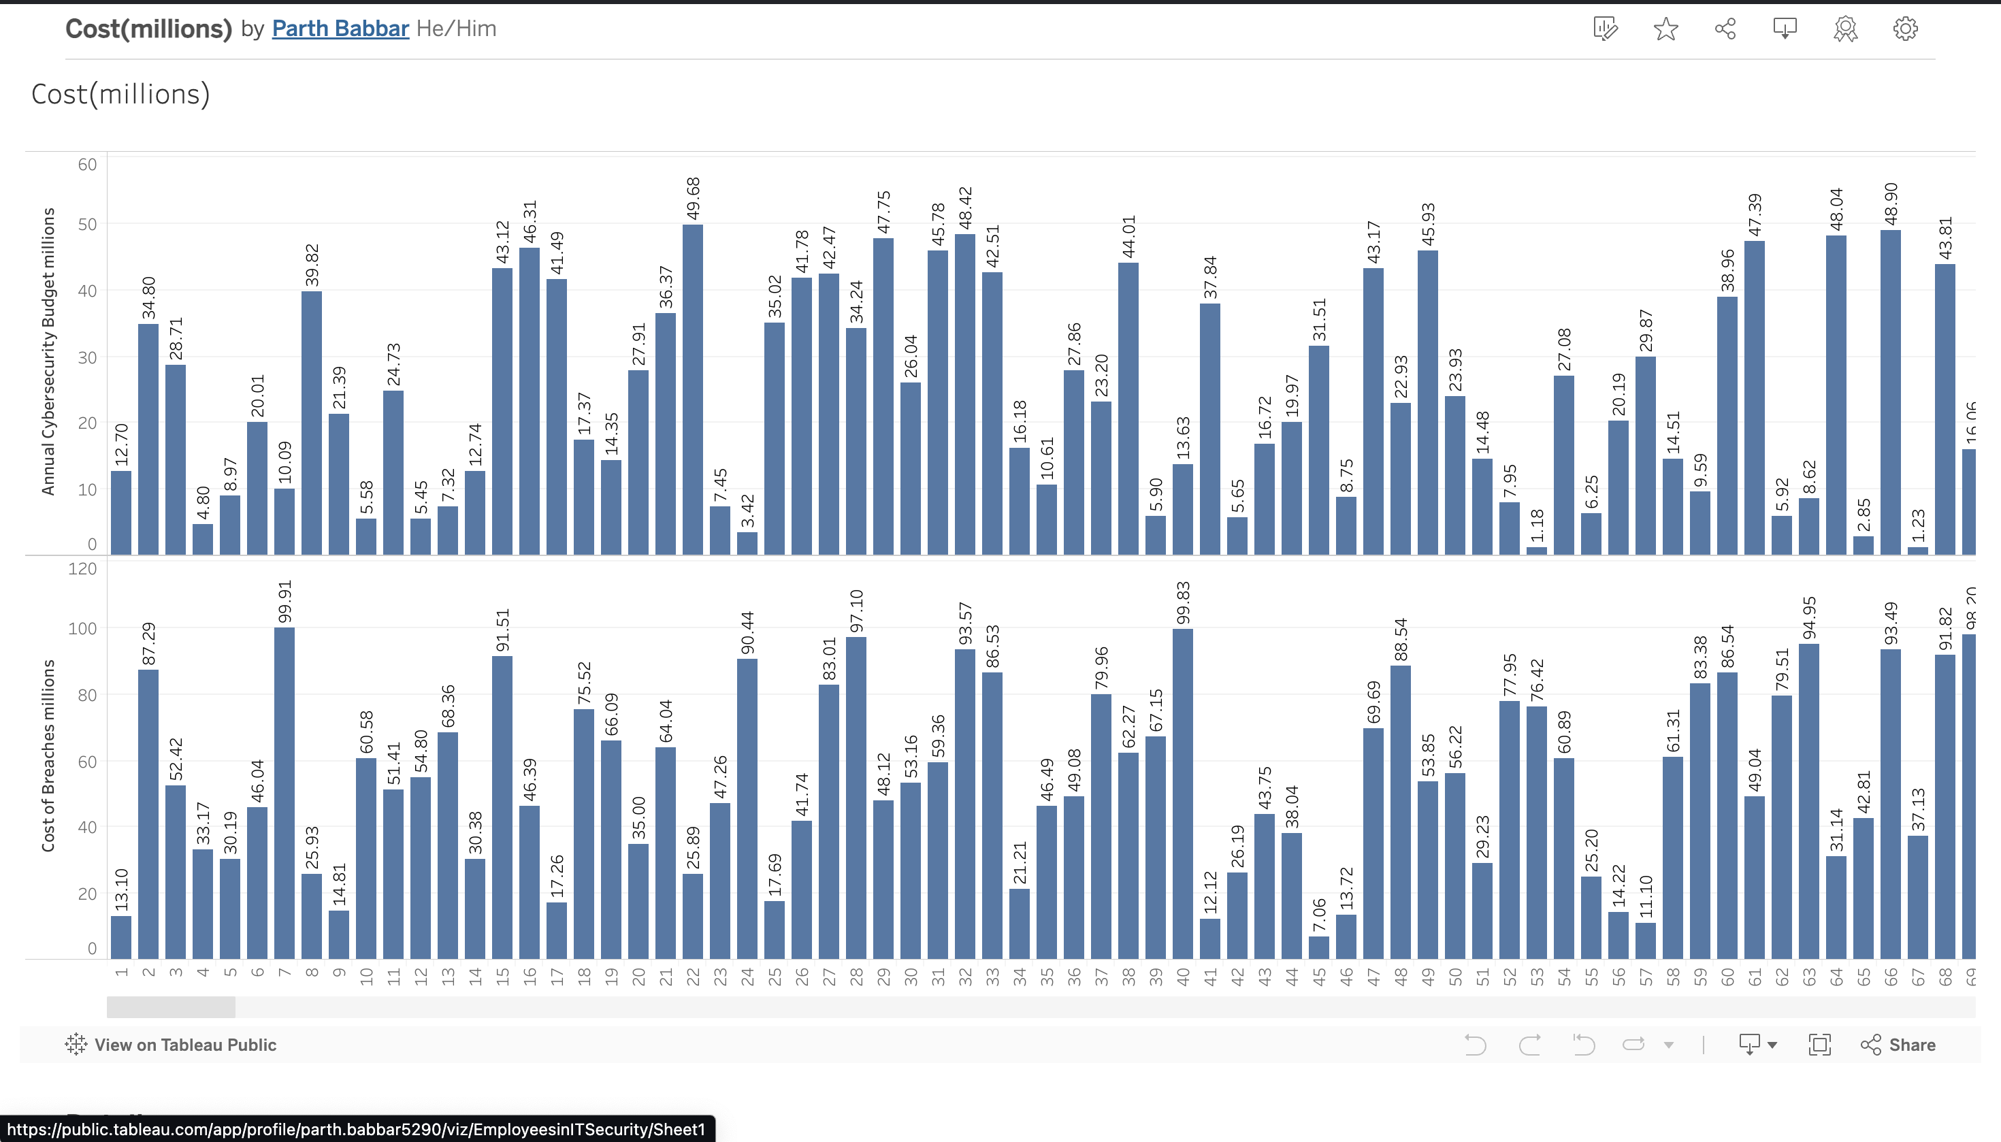

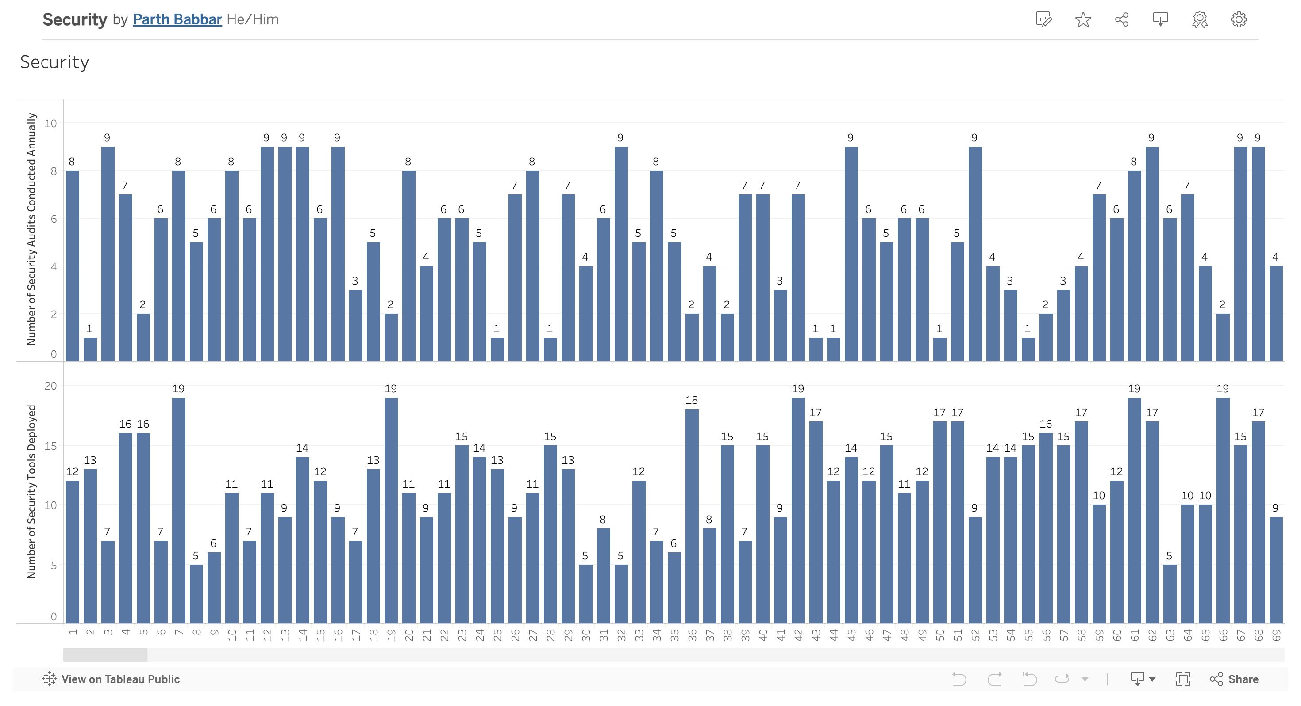
Result:
- The first bar chart shows that the bank has reported how many cybersecurity incidents in total.
- This chart shows whether the following bank is compliance with the security measures or not using 1 as Yes and 0 as No.
- This chart shows the percentage of banks users aware of the cybersecurity measures installed in the banking experience.
- This line graph shows 3 different incidents count for the following banks that are Phishing, Malware, and Ransomware that were reported.
- This dashboard tells the average time each bank takes to report and detect a cyber incident.
- This dashboard showcase the number of employees present in the IT sector to resolve cyber incidents.
- This dashboard shows the amount of budget given to each bank for cybersecurity measures in millions as well as the cost of breaches in millions.
- This dashboard shows the number of security audits conducted annually and security tools developed.
Summary:
The overall analysis of the dashboards are in following:
- Incident Frequency and Response: Banks experienced varying levels of cybersecurity problems, with bigger user populations or sophisticated IT systems leading to greater rates. The average reaction time to events proved crucial in reducing the effect of breaches. Banks with quicker reaction times claimed reduced expenses for breaches.
- Financial Impact: There found a clear association between the cost of breaches and the frequency of cybersecurity events. Banks with higher incident rates had bigger financial losses. Adequate spending for cybersecurity was required for efficient incident management. Banks with larger yearly cybersecurity expenditures showed improved incident response metrics
- Compliance and User Awareness: A bank's adherence to security standards is a key indicator of its cybersecurity posture. Banks that followed these guidelines reported fewer and lower-cost issues. User awareness levels were critical in preventing mishaps. Banks with a larger percentage of knowledgeable users saw fewer phishing and malware problems.
- Detection and Prevention: Faster detection times resulted in cheaper expenses and fewer breaches. Investing in sophisticated detection tools and training for IT security personnel was advantageous. Regular security audits and a wide set of security technologies helped to strengthen defensive mechanisms and speed up incident handling.

